Hospital Management System

ABSTRACT

OBJECTIVE :

Hospitals currently use a manual system for the management and maintenance of critical information. The current system requires numerous paper forms, with data stores spread throughout the hospital management infrastructure. Often information (on forms) is incomplete, or does not follow management standards. Forms are often lost in transit between departments requiring a comprehensive auditing process to ensure that no vital information is lost. Multiple copies of the same information exist in the hospital and may lead to inconsistencies in data in various data stores.
A significant part of the operation of any hospital involves the acquisition, management and timely retrieval of great volumes of information. This information typically involves; patient personal information and medical history, staff information, room and ward scheduling, staff scheduling, operating theater scheduling and various facilities waiting lists. All of this information must be managed in an efficient and cost wise fashion so that an institution's resources may be effectively utilized HMS will automate the management of the hospital making it more efficient and error free. It aims at standardizing data, consolidating data ensuring data integrity and reducing inconsistencies.

PROJECT OVERVIEW :

The Hospital Management System (HMS) is designed for Any Hospital to replace their existing manual, paper based system. The new system is to control the following information; patient information, room availability, staff and operating room schedules, and patient invoices. These services are to be provided in an efficient, cost effective manner, with the goal of reducing the time and resources currently required for such tasks.
A significant part of the operation of any hospital involves the acquisition, management and timely retrieval of great volumes of information. This information typically involves; patient personal information and medical history, staff information, room and ward scheduling, staff scheduling, operating theater scheduling and various facilities waiting lists. All of this information must be managed in an efficient and cost wise fashion so that an institution's resources may be effectively utilized HMS will automate the management of the hospital making it more efficient and error free. It aims at standardizing data, consolidating data ensuring data integrity and reducing inconsistencies.

SYSTEM DESIGN:
In this software we have developed some forms. The brief description about them is as follow:-

Reception:

The reception module handles various enquiries about the patient's admission and discharge details, bed census, and the patient's movements within the hospital. The system can also handle fixed-cost package deals for patients as well as Doctor Consultation and Scheduling, Doctor Consultancy Fees and Time Allocation.
- Doctor visit schedule
- Doctor Appointment Scheduling
- Enquiry of Patient
- Find History of Patient Enquired.

Administration:
This module handles all the master entry details for the hospital requirement such as consultation detail, doctor specialization, consultancy fee, and service charges.
Employee
- Employee Detail Recording.
- Doctor Type .
- Doctor Master
- Referral Doctor

Registration:
This module helps in registering information about patients and handling both IPD and OPD patient’s query. A unique ID is generated for each patient after registration. This helps in implementing customer relationship management and also maintains medical history of the patient.

SOFTWARE REQUIREMENTS :

Web Technologies : Jsp, Spring MVC ,Tiles, css

Language : Java, Spring MVC, Hibernate

Database : SQL SERVER 2005

Web Server : Apache tomcate

Operating System : WINDOWS

Introduction

INTRODUCTION:

Documenting the assembly, maintenance, use, and troubleshooting of a system as complex as a voting system is a difficult task. A single system might combine proprietary hardware, custom operating systems and software, commodity personal computers, and pen and paper. Describing these highly varied components is one function of voting system documentation. But it is not only voting system technology that is heterogeneous; so are voting systems users, and the environments in which the systems are used. Election officials, poll workers, and voters often need guidance from documents in order to administer or use a voting system. In addition, voting system certification—the process by which a system is approved for use in state— demands evidence that a voting system complies with one or more sets of standards or guidelines.

Documentation provides the details that certification bodies need to evaluate the
System. Taken as a whole, voting system documentation must explain the system in several ways to meet the needs of these multiple audiences.

As the modern organizations are automated and computers are working as per the instructions, it becomes essential for the coordination of human beings, commodity and computers in a modern organization.

Many big cities where the life is busy needs the transaction of the goods within few minutes of time. So, this online information recorded by the distributor helps him to complete this task within the time.

The administrators and all the others can communicate with the system through this project, thus facilitating effective implementation and monitoring of various activities of the voting Software.

Analysis

1. Existing System

Hospitals currently use a manual system for the management and maintenance of critical information. The current system requires numerous paper forms, with data stores spread throughout the hospital management infrastructure. Often information (on forms) is incomplete, or does not follow management standards. Forms are often lost in transit between departments requiring a comprehensive auditing process to ensure that no vital information is lost. Multiple copies of the same information exist in the hospital and may lead to inconsistencies in data in various data stores.

2. Proposed System

The Hospital Management System (HMS) is designed for Any Hospital to replace their existing manual, paper based system. The new system is to control the following information; patient information, room availability, staff and operating room schedules, and patient invoices. These services are to be provided in an efficient, cost effective manner, with the goal of reducing the time and resources currently required for such tasks.

3. Objective of the System

Hospitals currently use a manual system for the management and maintenance of critical information. The current system requires numerous paper forms, with data stores spread throughout the hospital management infrastructure. Often information (on forms) is incomplete, or does not follow management standards. Forms are often lost in transit between departments requiring a comprehensive auditing process to ensure that no vital information is lost. Multiple copies of the same information exist in the hospital and may lead to inconsistencies in data in various data stores.
A significant part of the operation of any hospital involves the acquisition, management and timely retrieval of great volumes of information. This information typically involves; patient personal information and medical history, staff information, room and ward scheduling, staff scheduling, operating theater scheduling and various facilities waiting lists. All of this information must be managed in an efficient and cost wise fashion so that an institution's resources may be effectively utilized HMS will automate the management of the hospital making it more efficient and error free. It aims at standardizing data, consolidating data ensuring data integrity and reducing inconsistencies.
.

System Specifications

Hardware Requirements:-

- Pentium-IV(Processor).
- 256 MB Ram
- 512 KB Cache Memory
- Hard disk 10 GB
- Microsoft Compatible 101 or more Key Board

Software Requirements: -

- Operating System : Windows
- Programming language: Java
- Web-Technology: Spring MVC, html, css
- Front-End: html,Tiles
- Back-End: Java,Spring MVC,Hibernate , jdbc
- Web Server: Apache tomcate

DESIGN

INTRODUCTION:

Design is the first step in the development phase for any techniques and principles for the purpose of defining a device, a process or system in sufficient detail to permit its physical realization.

Once the software requirements have been analyzed and specified the software design involves three technical activities - design, coding, implementation and testing that are required to build and verify the software.

The design activities are of main importance in this phase, because in this activity, decisions ultimately affecting the success of the software implementation and its ease of maintenance are made. These decisions have the final bearing upon reliability and maintainability of the system. Design is the only way to accurately translate the customer’s requirements into finished software or a system.

Design is the place where quality is fostered in development. Software design is a process through which requirements are translated into a representation of software. Software design is conducted in two steps. Preliminary design is concerned with the transformation of requirements into data.
UML Diagrams:
Actor:
A coherent set of roles that users of use cases play when interacting with the use `cases.

Use case:
A description of sequence of actions, including variants, that a system performs that yields an observable result of value of an actor.

UML stands for Unified Modeling Language. UML is a language for specifying, visualizing and documenting the system. This is the step while developing any product after analysis. The goal from this is to produce a model of the entities involved in the project which later need to be built. The representation of the entities that are to be used in the product being developed need to be designed.
There are various kinds of methods in software design:
They are as follows:
- Use case Diagram
- Sequence Diagram
- Collaboration Diagram

USECASE DIAGRAMS:

Use case diagrams model behavior within a system and helps the developers understand of what the user require. The stick man represents what’s called an actor.
Use case diagram can be useful for getting an overall view of the system and clarifying who can do and more importantly what they can’t do.
Use case diagram consists of use cases and actors and shows the interaction between the use case and actors.

- The purpose is to show the interactions between the use case and actor.
- To represent the system requirements from user’s perspective.
- An actor could be the end-user of the system or an external system.

USECASE DIAGRAM:

A Use case is a description of set of sequence of actions Graphically it is rendered as an ellipse with solid line including only its name. Use case diagram is a behavioral diagram that shows a set of use cases and actors and their relationship. It is an association between the use cases and actors. An actor represents a real-world object.

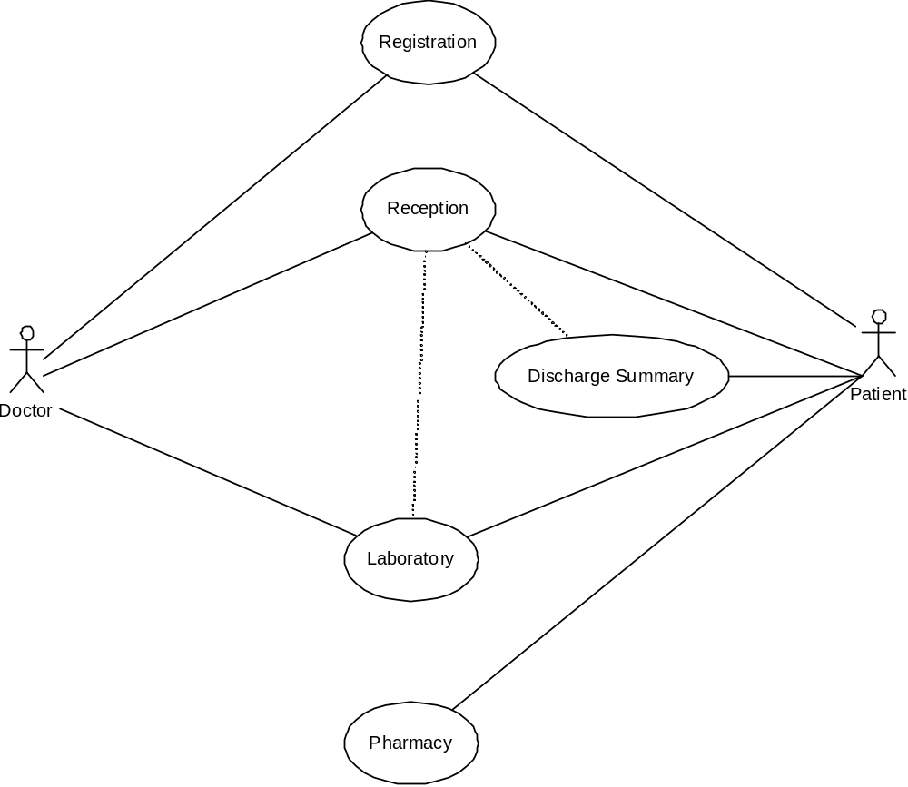

SEQUENCE DIAGRAM:

Sequence diagram and collaboration diagram are called INTERACTION DIAGRAMS. An interaction diagram shows an interaction, consisting of set of objects and their relationship including the messages that may be dispatched among them.
A sequence diagram is an introduction that empathizes the time ordering of messages. Graphically a sequence diagram is a table that shows objects arranged along the X-axis and messages ordered in increasing time along the Y-axis

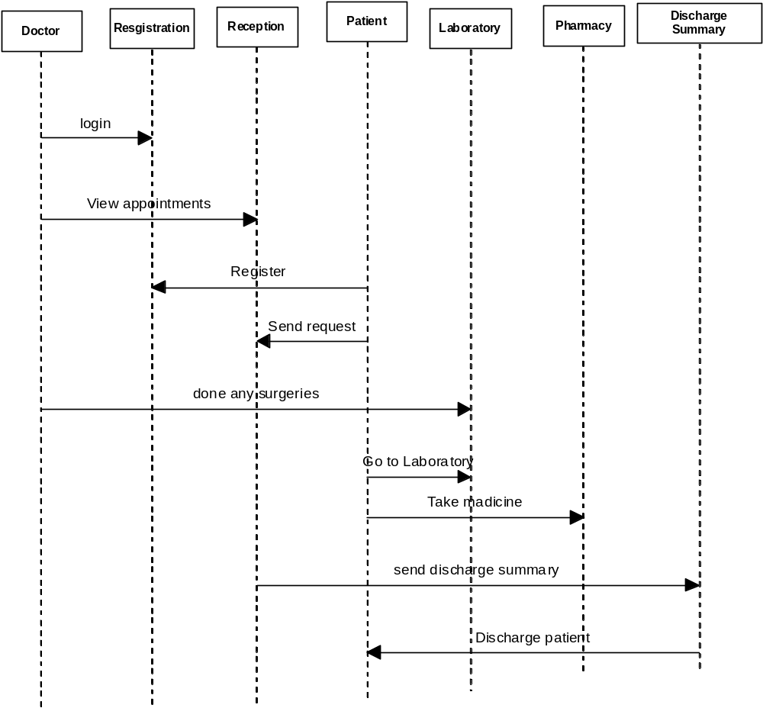

DATA FLOW DIAGRAMS:

The DFD takes an input-process-output view of a system i.e. data objects flow into the software, are transformed by processing elements, and resultant data objects flow out of the software.

Data objects represented by labeled arrows and transformation are represented by circles also called as bubbles. DFD is presented in a hierarchical fashion i.e. the first data flow model represents the system as a whole. Subsequent DFD refine the context diagram (level 0 DFD), providing increasing details with each subsequent level.

The DFD enables the software engineer to develop models of the information domain & functional domain at the same time. As the DFD is refined into greater levels of details, the analyst perform an implicit functional decomposition of the system. At the same time, the DFD refinement results in a corresponding refinement of the data as it moves through the process that embody the applications.

A context-level DFD for the system the primary external entities produce information for use by the system and consume information generated by the system. The labeled arrow represents data objects or object hierarchy.

RULES FOR DFD:

- Fix the scope of the system by means of context diagrams.

- Organize the DFD so that the main sequence of the actions

- Reads left to right and top to bottom.

- Identify all inputs and outputs.

- Identify and label each process internal to the system with Rounded circles.

- A process is required for all the data transformation and Transfers. Therefore, never connect a data store to a data Source or the destinations or another data store with just a Data flow arrow.

- Do not indicate hardware and ignore control information.

- Make sure the names of the processes accurately convey everything the process is done.

- There must not be unnamed process.

- Indicate external sources and destinations of the data, with Squares.

- Number each occurrence of repeated external entities.

- Identify all data flows for each process step, except simple Record retrievals.

- Label data flow on each arrow.

- Use details flow on each arrow.

- Use the details flow arrow to indicate data movements.

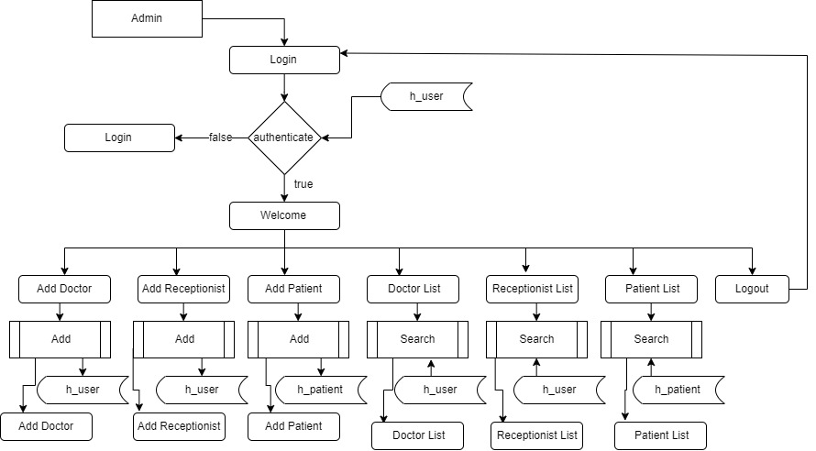

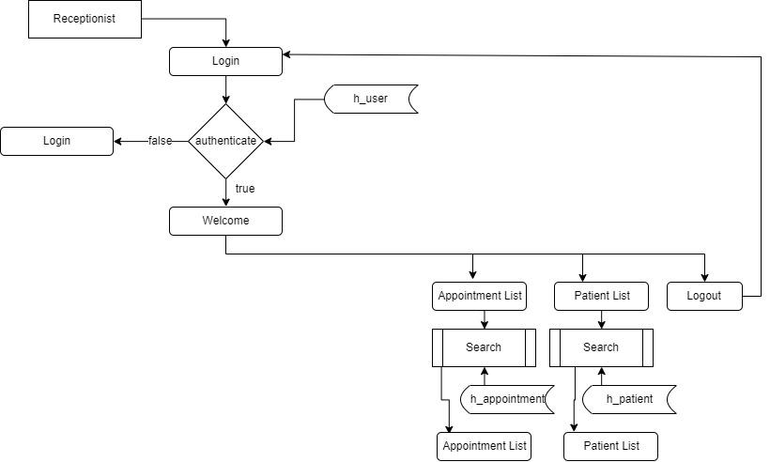

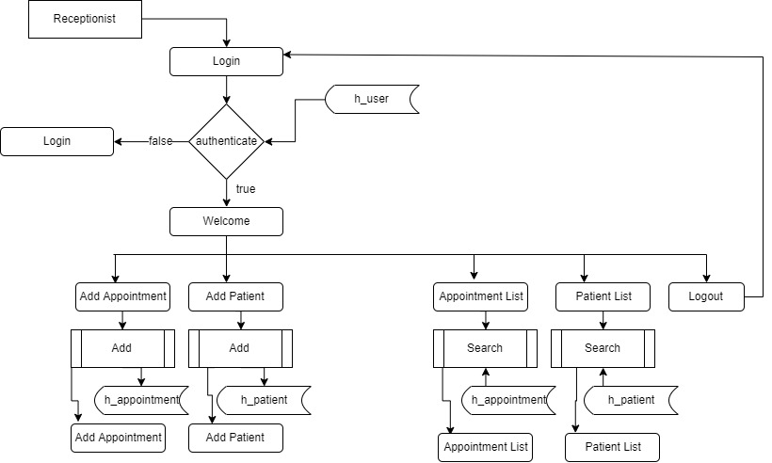

E-R Diagrams:
The Entity-Relationship (ER) model was originally proposed by Peter in 1976 [Chen76] as a way to unify the network and relational database views. Simply stated the ER model is a conceptual data model that views the real world as entities and relationships. A basic component of the model is the Entity-Relationship diagram which is used to visually represents data objects. Since Chen wrote his paper the model has been extended and today it is commonly used for database design For the database designer, the utility of the ER model is:
- it maps well to the relational model. The constructs used in the ER model can easily be transformed into relational tables.
- it is simple and easy to understand with a minimum of training. Therefore, the model can be used by the database designer to communicate the design to the end user.
- In addition, the model can be used as a design plan by the database developer to implement a data model in a specific database management software.

Connectivity and Cardinality
The basic types of connectivity for relations are: one-to-one, one-to-many, and many-to-many. A one-to-one (1:1) relationship is when at most one instance of a entity A is associated with one instance of entity B. For example, "employees in the company are each assigned their own office. For each employee there exists a unique office and for each office there exists a unique employee.
A one-to-many (1:N) relationships is when for one instance of entity A, there are zero, one, or many instances of entity B, but for one instance of entity B, there is only one instance of entity A. An example of a 1:N relationships is
a department has many employees
each employee is assigned to one department
A many-to-many (M:N) relationship, sometimes called non-specific, is when for one instance of entity A, there are zero, one, or many instances of entity B and for one instance of entity B there are zero, one, or many instances of entity A. The connectivity of a relationship describes the mapping of associated

ER Notation
There is no standard for representing data objects in ER diagrams. Each modeling methodology uses its own notation. The original notation used by Chen is widely used in academics texts and journals but rarely seen in either CASE tools or publications by non-academics. Today, there are a number of notations used, among the more common are Bachman, crow's foot, and IDEFIX.
All notational styles represent entities as rectangular boxes and relationships as lines connecting boxes. Each style uses a special set of symbols to represent the cardinality of a connection. The notation used in this document is from Martin. The symbols used for the basic ER constructs are:
- entities are represented by labeled rectangles. The label is the name of the entity. Entity names should be singular nouns.
- relationships are represented by a solid line connecting two entities. The name of the relationship is written above the line. Relationship names should be verbs
- attributes, when included, are listed inside the entity rectangle. Attributes which are identifiers are underlined. Attribute names should be singular nouns.
- cardinality of many is represented by a line ending in a crow's foot. If the crow's foot is omitted, the cardinality is one.
- existence is represented by placing a circle or a perpendicular bar on the line. Mandatory existence is shown by the bar (looks like a 1) next to the entity for an instance is required. Optional existence is shown by placing a circle next to the entity that is optional

MODULES

PROJECT MODULES

- Reception
- Administration
- Doctor
- Registration
- Patient

MODULE DESCRIPTION

Name of the module-1: Reception

Description: The reception module handles various enquiries about the patient's admission and discharge details, bed census, and the patient's movements within the hospital. The system can also handle fixed-cost package deals for patients as well as Doctor Consultation and Scheduling, Doctor Consultancy Fees and Time Allocation
Sub modules:
- Doctor visit schedule
- Doctor Appointment Scheduling
- Enquiry of Patient
- Find History of Patient Enquired.

Name of the module-2: Administration

Description: This module handles all the master entry details for the hospital requirement such as consultation detail, doctor specialization, consultancy fee, and service charges.
Employee

Sub modules:
- Employee Detail Recording.
- Doctor Type .
- Doctor Master
- Referral Doctor

Name of the module-3: Pharmacy
Description: This module deals with all medical items. This module helps in maintaining Item Master, Receipt of Drugs/consumables, issue, handling of material return, generating retail bills, stock maintenance. It also helps in fulfilling the requirements of both IPD and OPD Pharmacy.

Name of the module-4: Doctor
Description: This module enables the maintenance of investigation requests by the patient and generation of test results for the various available services, such as clinical pathology, X-ray and ultrasound tests. Requests can be made from various points, including wards, billing, sample collection and the laboratory receiving point. The laboratory module is integrated with the in-patient/ outpatient registration, wards and billing modules.

Name of the module-5: Registration.
Description: This module helps in registering information about patients and handling both IPD and OPD patient’s query. A unique ID is generated for each patient after registration. This helps in implementing customer relationship management and also maintains medical history of the patient.

Name of the module-6: Patient
Description: The module helps in generating patient’s discharge summary, which includes patient’s health at the time of discharge, medical history, various diagnosis and drug prescriptions, history of present illness and course in hospital.

3.2 BACK END TECHNOLOGY:
About Microsoft SQL Server 2000
Microsoft SQL Server is a Structured Query Language (SQL) based, client/server relational database. Each of these terms describes a fundamental part of the architecture of SQL Server.
Database
A database is similar to a data file in that it is a storage place for data. Like a data file, a database does not present information directly to a user; the user runs an application that accesses data from the database and presents it to the user in an understandable format.
A database typically has two components: the files holding the physical database and the database management system (DBMS) software that applications use to access data. The DBMS is responsible for enforcing the database structure, including:
- Maintaining the relationships between data in the database.
- Ensuring that data is stored correctly and that the rules defining data relationships are not violated.
- Recovering all data to a point of known consistency in case of system failures.

Databases
A database in Microsoft SQL Server consists of a collection of tables that contain data, and other objects, such as views, indexes, stored procedures, and triggers, defined to support activities performed with the data. The data stored in a database is usually related to a particular subject or process, such as inventory information for a manufacturing warehouse.

SQL Server can support many databases, and each database can store either interrelated data or data unrelated to that in the other databases. For example, a server can have one database that stores personnel data and another that stores product-related data. Alternatively, one database can store current customer order data, and another; related database can store historical customer orders that are used for yearly reporting. Before you create a database, it is

Important to understand the parts of a database and how to design these parts to ensure that the database performs well after it is implemented.

Normalization theory:
Relations are to be normalized to avoid anomalies. In insert, update and delete operations. Normalization theory is built around the concept of normal forms. A relation is said to be in a particular form if it satisfies a certain specified set if constraints. To decide a suitable logical structure for given database design the concept of normalization, which are briefly described below.

- 1st Normal Form (1 N.F): A relation is said to be in 1 NF is and only if all unaligned domains contain values only. That is the fields of an n-set should have no group items and no repeating groups.
- 2nd Normal Form (2 N.F) : A relation is said to be in 2 NF is and only if it is in 1 NF and every non key attribute is fully dependent on primary key. This normal takes care of functional dependencies on non-key attributes.
- 3 rd Normal Form (3 N.F) : A relation is said to be in 3 NF is and only if it is in 2 NF and every non key attribute is non transitively dependent on the primary key. This normal form avoids the transitive dependencies on the primary key.
- Boyce code Normal Form (BCNF) : This is a stronger definition than that of NF. A relation is said to be in BCNF if and only if every determinant is a Candidate key.
5. 4th Normal Form (4 NF) : A relation is said to be in 4 NF if and only if whenever there exists a multi valued dependency in a relation say A->->B then all of the relation are also functionally dependent on A(i.e. A->X for all attributes x of the relation.).
6. 5th Normal Form (5 NF) OR Projection Join Normal Form (PJNF): A relation R is in 5 NF .if and only if every join dependency in R is implied by the candidate key on R . A relation can’t be non-loss split into two tables but can be split into three tables. This is called Join Dependency.

Functions

Functions are bet declared between the <Head> tag of HTML page. Functions are called by user-initiated events. Seems reasonable to keep the functions between the <Head> tags. They are loaded first before a user can do anything that might call a function. Scripts can be placed between inside comment fields to ensure that older browser do not display the script itself.

<html>
<head>
<script language=”JavaScript”>
function pushbutton (){
alert (“Hello!”);
}
</script>
</head>
<body>
<form>
<input type=”button” name=”Button1” value=”push me” onclick=”pushbutton ()”>
</form>
</body>
</html>

If we want to test this one immediately and you are using a Java Script enabled browser then please go ahead and push the button.
This script will create a button and when you press it a window will pop up saying “hello!”. In fact we have a lot of possibilities just by adding functions to our scripts.
The common browsers transmit the form information by either method: here’s the complete tag including the GET transmission method attribute for the previous form

Example:

<Form method =GET action=http://www.mycompany.com/cgi-bin/upfdate.pl>
………
</form>

Input elements.

Use the <input> tag to define any one of a number of common form elements including text fields multiple choice lists click able images and submission buttons. There are many attributers for this tag only that types and name attributes are required for each element, each type of input element uses only a subset of the followed attributes. Additional <input> attributes may be required based upon which type of the form element you specify.

Submit button:

The submit button (<input type=submit> ) does what its name implies, settings in motion the form’s submission to the server from the browser. We many have more than submit buttons will be added to the parameter list the browser sends along to the server.

Example
< Input type =”submit”>
<Input type=”submit” value=”submit” name=”name”>

Reset button:

The reset button if firm <input> button is nearly self- explanatory; it lets the user reset erase or set to some default value all elements in the form. By default the browser displays a reset button worth the label “reset”. We can change that by specifying a value attribute with tour own button label.

Database Tables

DATABASE TABLES:

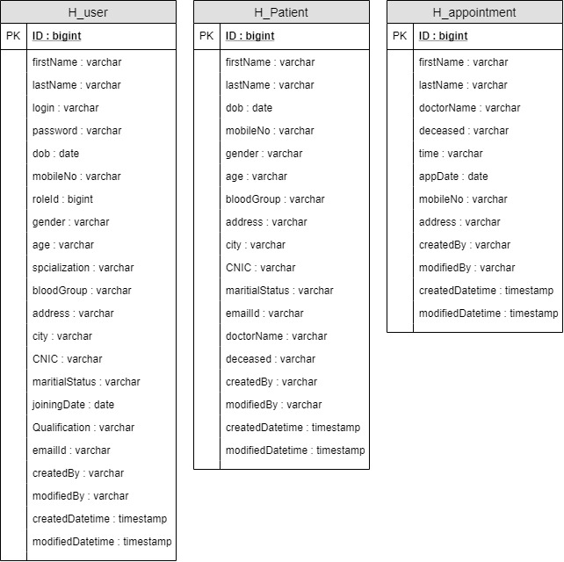

SOFTWARE METHODOLOGY

The software methodology followed in this project includes the object-oriented methodology and the application system development methodologies. The description of these methodologies is given below.

Application System Development – A Life cycle Approach

Although there are a growing number of applications (such as decision support systems) that should be developed using an experimental process strategy such as prototyping, a significant amount of new development work continue to involve major operational applications of broad scope. The application systems are large highly structured. User task comprehension and developer task proficiency is usually high. These factors suggest a linear or iterative assurance strategy. The most common method for this stage class of problems is a system development life cycle modal in which each stage of development is well defined and has straightforward requirements for deliverables, feedback and sign off. The system development life cycle is described in detail since it continues to be an appropriate methodology for a significant part of new development work.

The basic idea of the system development life cycle is that there is a well-defined process by which an application is conceived and developed and implemented. The life cycle gives structure to a creative process. In order to manage and control the development effort, it is necessary to know what should have been done, what has been done, and what has yet to be accomplished. The phrases in the system development life cycle provide a basis for management and control because they define segments of the
flow of work, which can be identified for managerial purposes and specifies the documents or other deliverables to be produced in each phase.

The phases in the life cycle for information system development are described differently by different writers, but the differences are primarily in the amount of necessity and manner of categorization. There is a general agreement on the flow of development steps and the necessity for control procedures at each stage.
The information system development cycle for an application consists of three major stages.

- Definition.
- Development
- Installation and operation

The first stage of the process, which defines the information requirements for a feasible cost effective system. The requirements are then translated into a physical system of forms, procedures, programs etc., by the system design, computer programming and procedure development. The resulting system is test and put into operation. No system is perfect so there is always a need for maintenance changes. To complete the cycle, there should be a post audit of the system to evaluate how well it performs and how well it meets the cost and performance specifications. The stages of definition, development and installation and operation can therefore be divided into smaller steps or phrases as follows.
Definition
Proposed definition : preparation of request for proposed applications.
Feasibility assessment : evaluation of feasibility and cost benefit of proposed system.
Information requirement analysis : determination of information needed.
Design
Conceptual design : User-oriented design of application development.
Physical system design : Detailed design of flows and processes in applications processing system and preparation of program specification.
Development
Program development : coding and testing of computer programs.
Procedure development : design of procedures and preparation of user instructions.

Installation and operation

Conversion : final system test and conversion.
Operation and maintenance : Month to month operation and maintenance
Post audit : Evaluation of development process,application system and results of use at the completion of the each phase, formal approval sign-off is required from the users as well as from the manager of the project development.

OUTPUT SCREENS

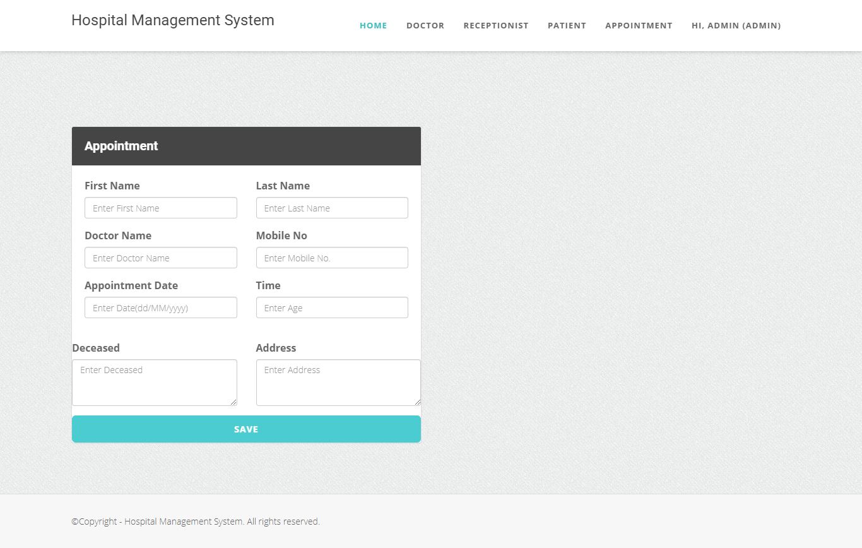

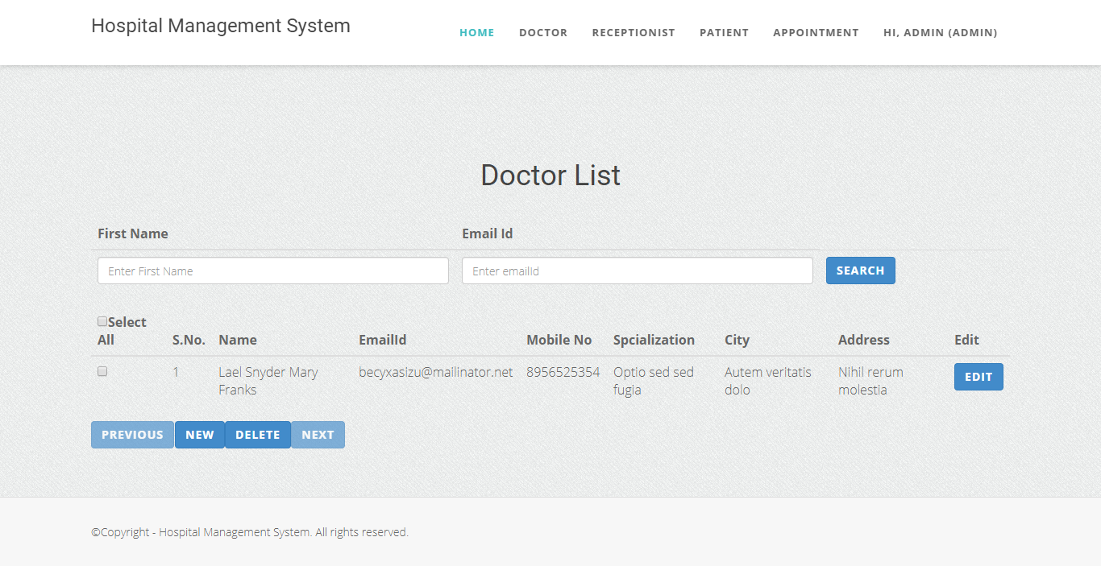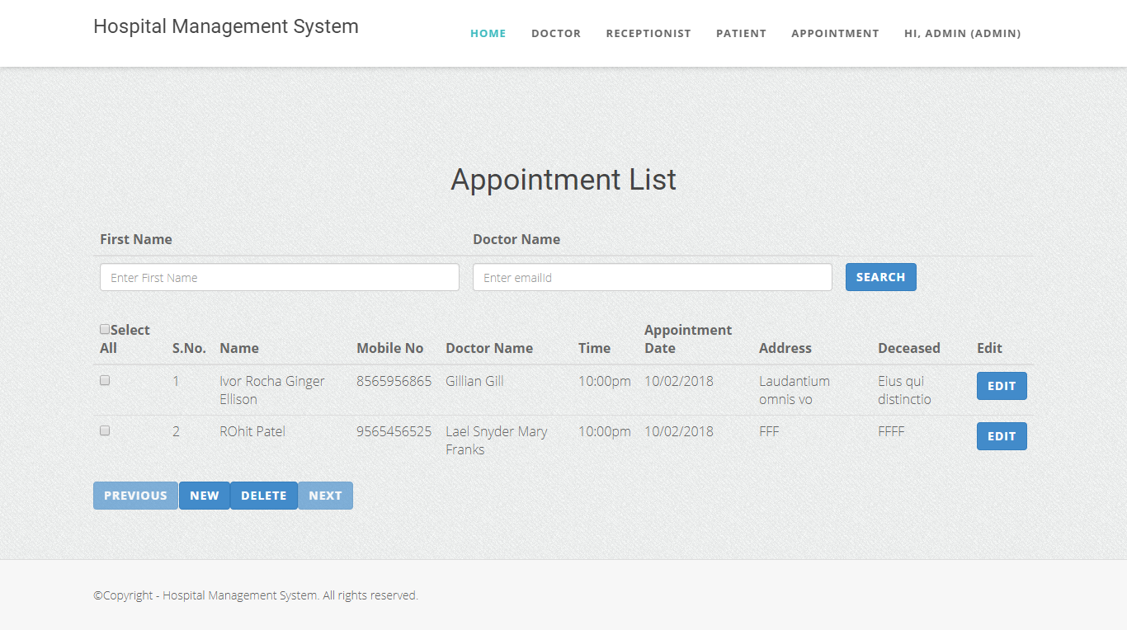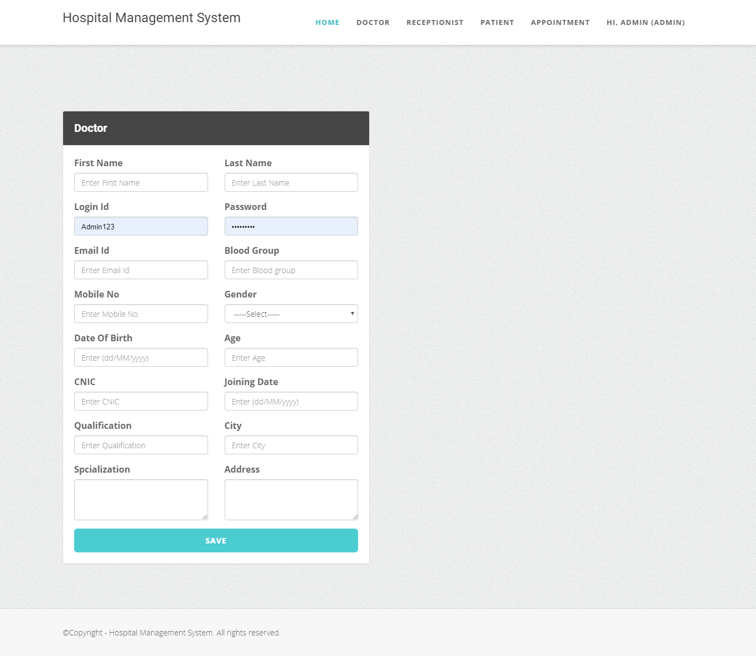

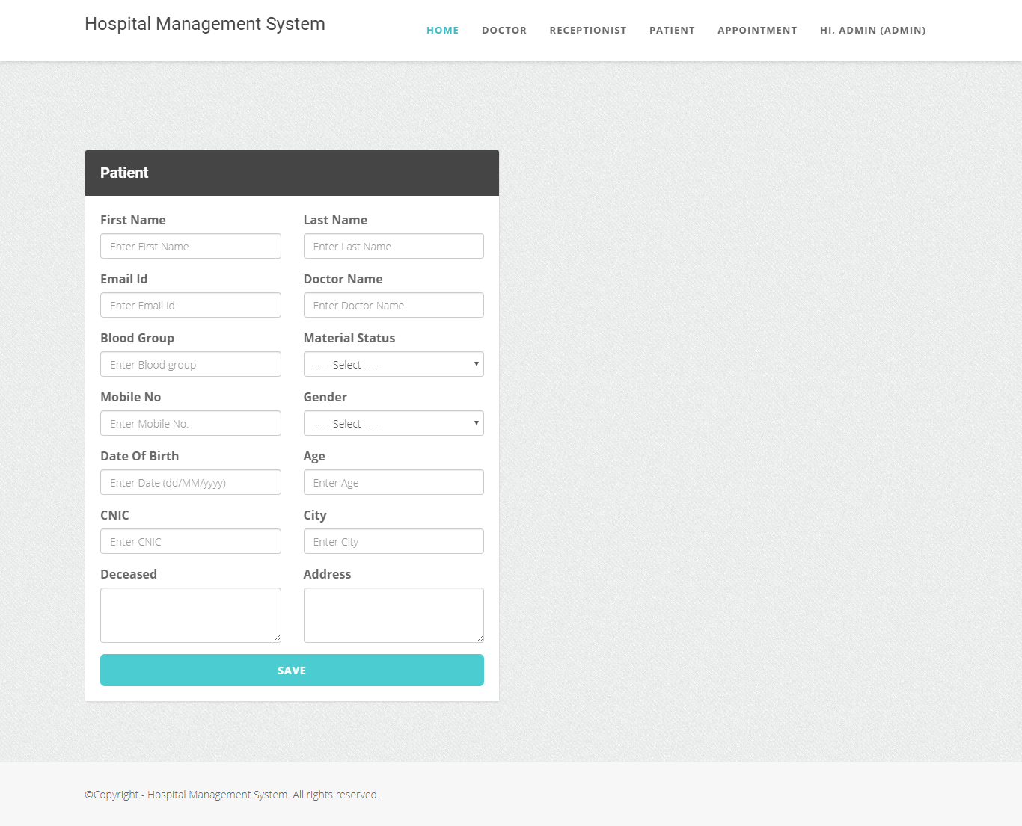

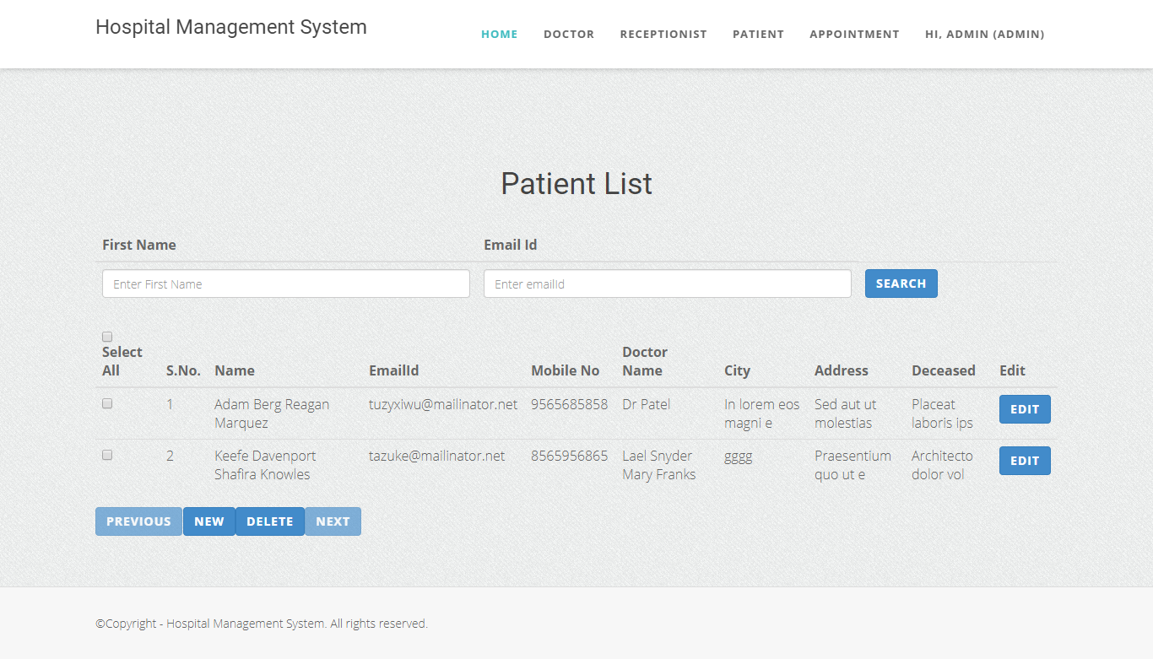

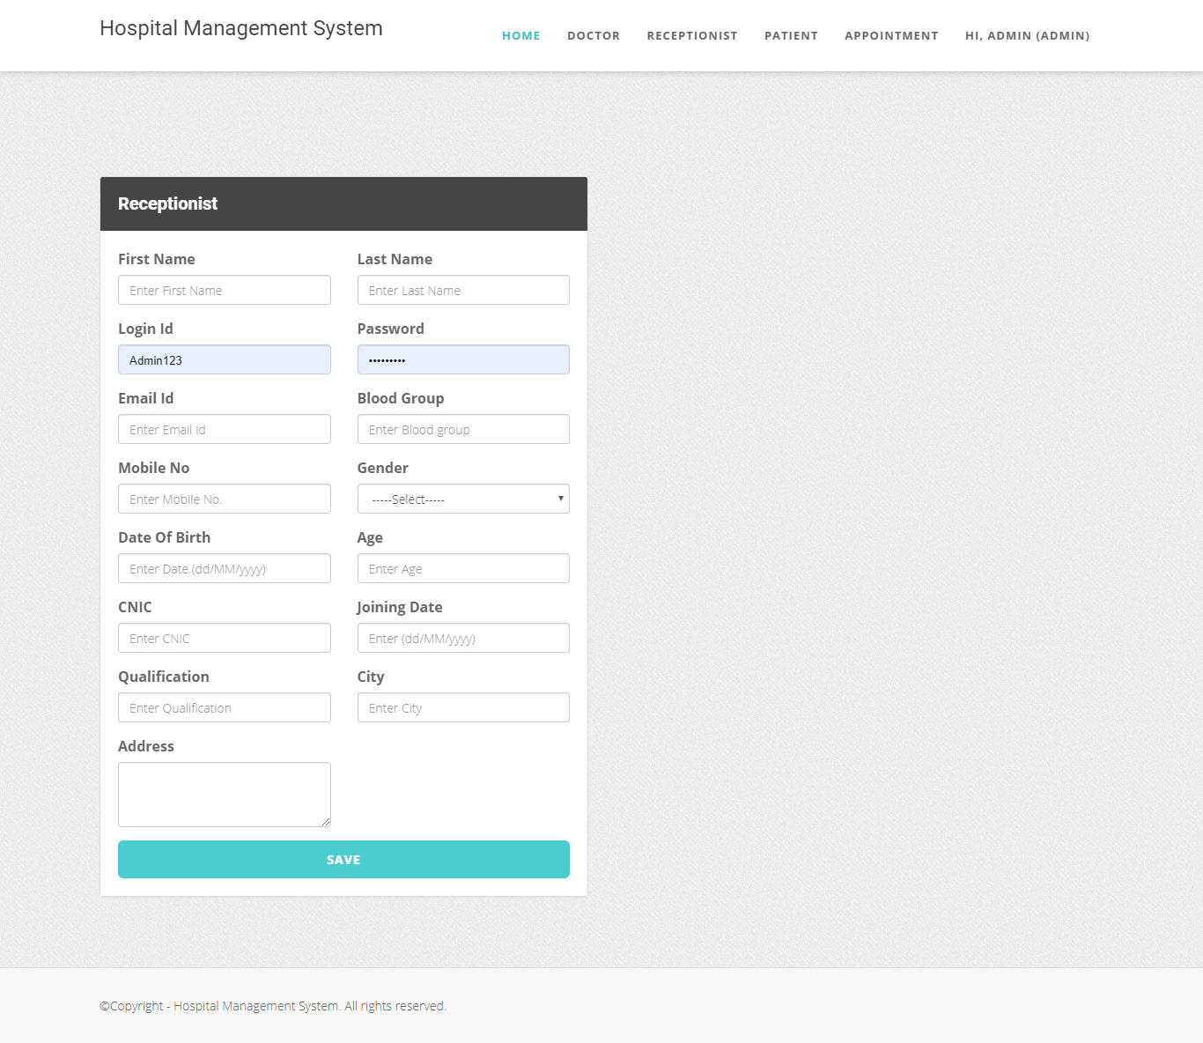

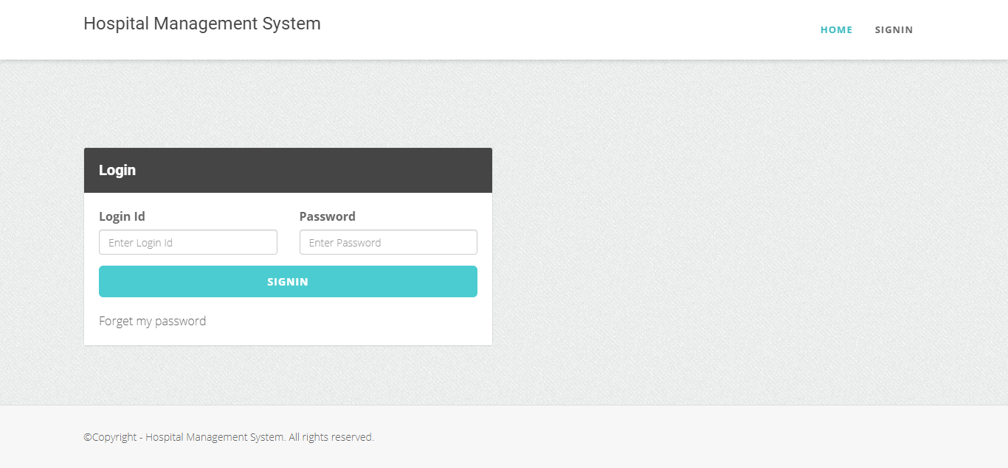

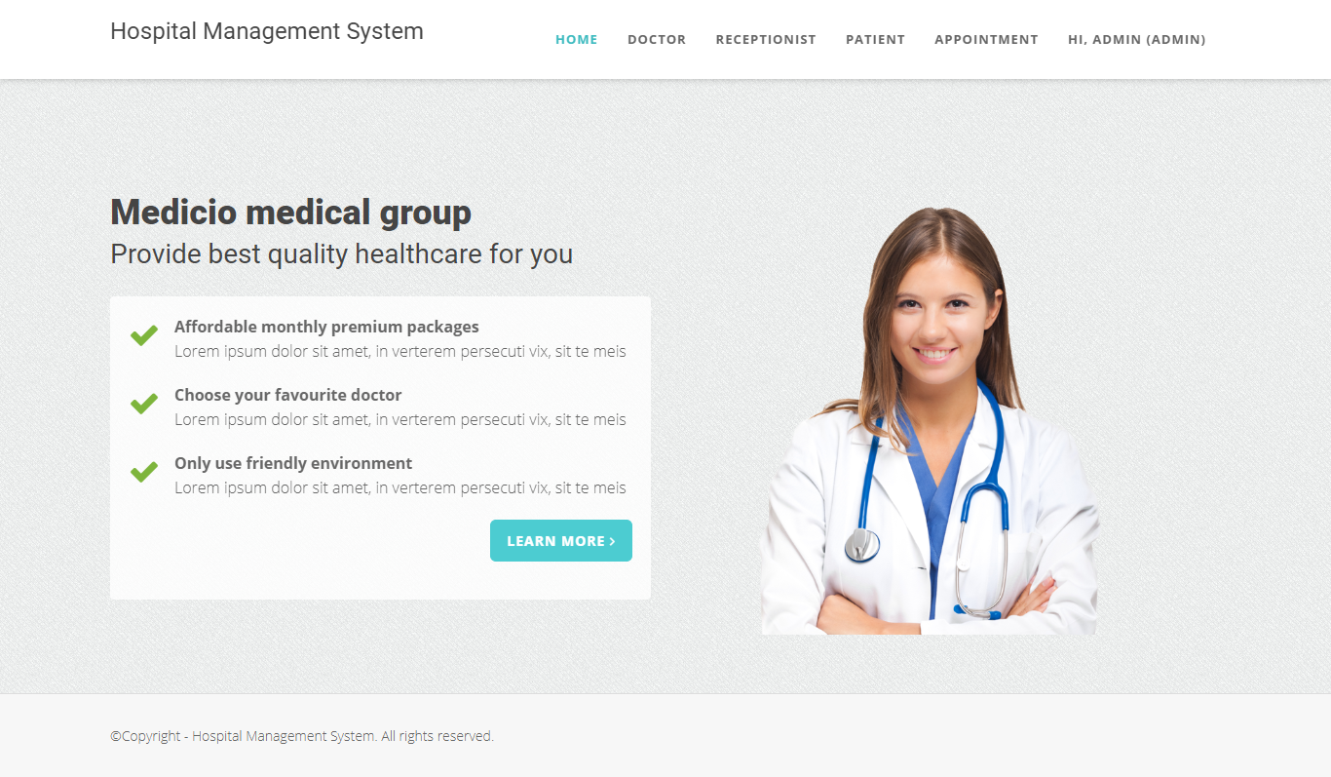

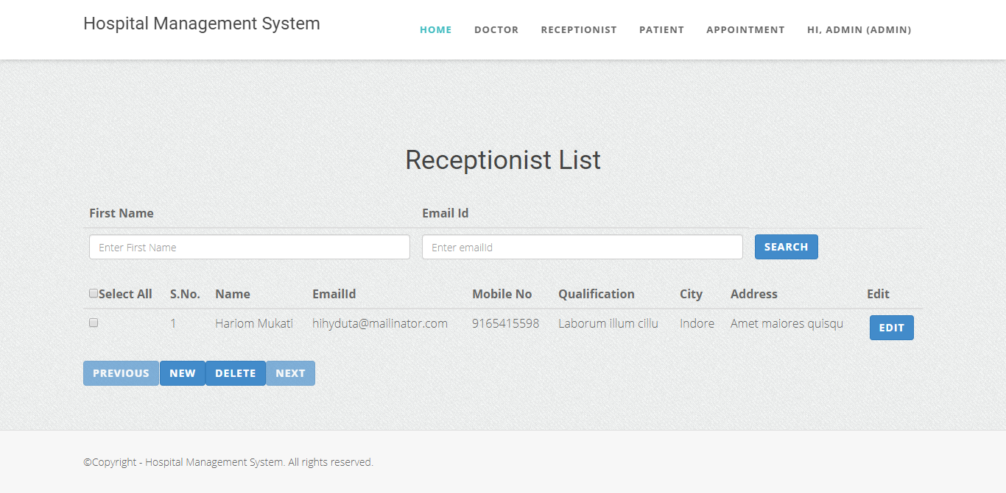

CONCLUSION

CONCLUSION:

The package was designed in such a way that future modifications can be done easily. The following conclusion can be deduced from the development of the project.

  - Automation of the entire system improves the efficiency
  - It provides a friendly graphical user interface which proves to be better when compared to the existing system.
  - It gives appropriate access to the authorized users depending on their permissions.
  - It effectively overcomes the delay in communications.
  - Updating of information becomes so easier.
  - System security, data security and reliability are the striking features.
  - The System has adequate scope for modification in future if it is necessary.

FUTURE ENHANCEMENTS

FUTURE ENHANCEMENTS:

This application avoids the manual work and the problems concern with it. It is an easy way to obtain the information regarding the various travel services that are present in our System.
Well I and my team member have worked hard in order to present an improved website better than the existing one’s regarding the information about the various activities. Still, we found out that the project can be done in a better way. Primarily, In this system patient login and then go to reception. By using this patient will send request for consulting the doctor. Reception will set the date for doctor appointments. After that doctor see his appointments and see the patients, surgeries also done.
The next enhancement is, we will develop online services. That mean, if patient have any problems he can send his problem to the doctor through internet from his home then doctor will send reply to him. In this patients have some login name and password.

